
Guidance for Parents: How the School Manages Unexplained Absences
Why Attendance Matters
Regular attendance is essential for your child’s learning and wellbeing. If your child cannot attend school, please inform us as soon as possible.
What Happens if Your Child is Absent Without Explanation?
- Morning Registration Check
  - Attendance is taken at the start of the school day.
  - If your child is absent and we have not received a reason from you, this is recorded as an unexplained absence.
- Initial Contact (Within 30–60 Minutes of Registration)
  - The school will attempt to contact you by phone and/or text message using the contact details provided.
  - If we cannot reach you, we will try all available numbers, including emergency contacts.
- Escalation if No Response (Within 2 Hours of Registration)
  - If we still have no explanation, the absence is flagged as a potential safeguarding concern.
  - A member of staff will conduct a risk assessment, considering:
    - Your child’s age and any known vulnerabilities.
    - Previous attendance patterns.
    - Any safeguarding alerts on record.
- Further Action (Same Day)
  - If risk is assessed as low, we will continue attempts to contact you throughout the day.
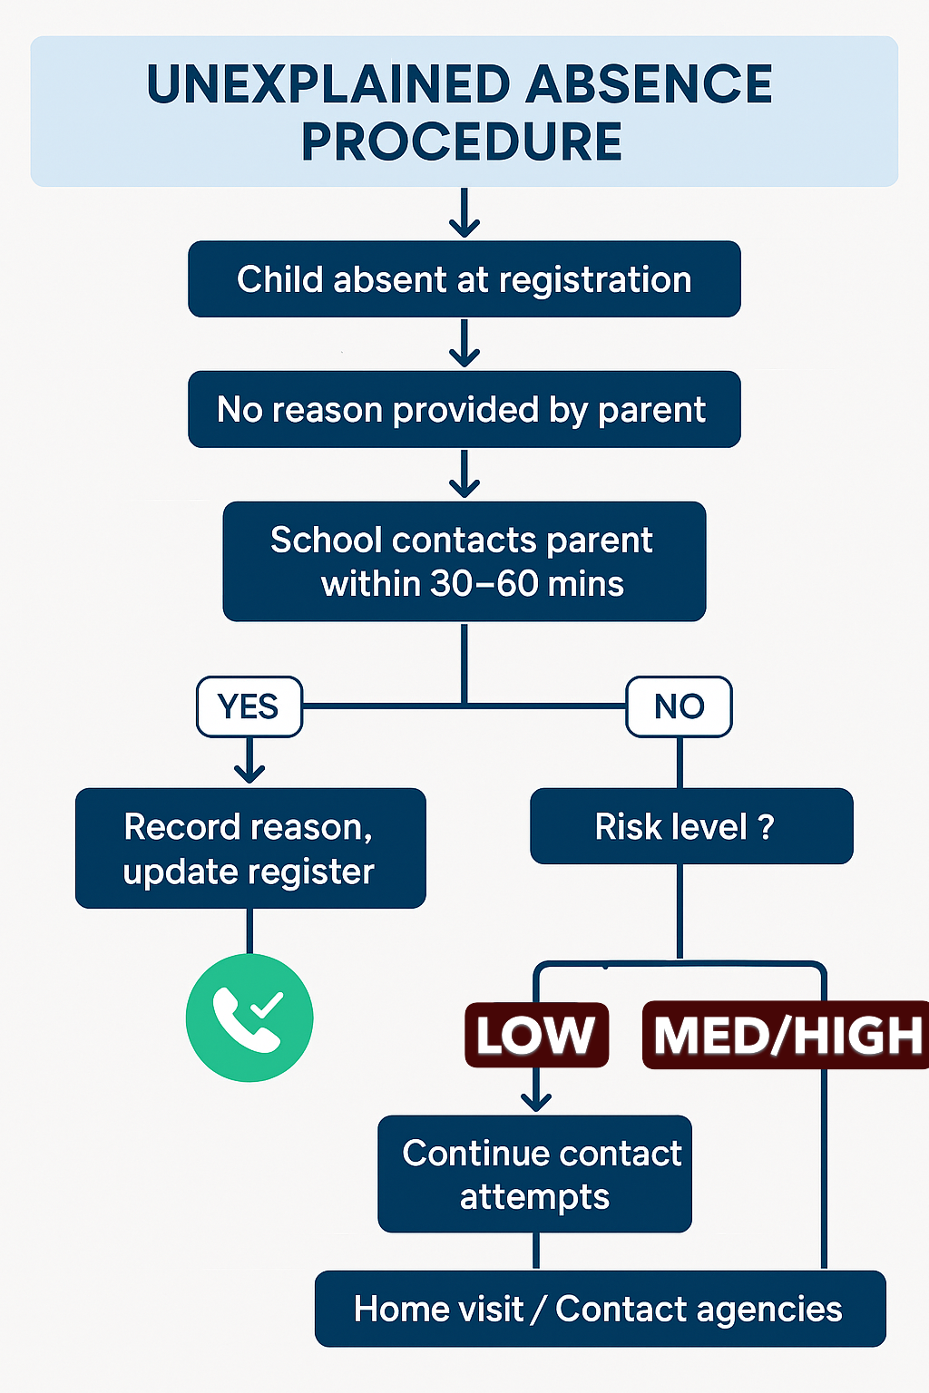
  - If risk is assessed as medium/high, we may:
    - Make a home visit.
    - Contact other agencies (e.g., social services, police) if we believe your child may be at risk.

